Rabbit and cat
One Monday morning, Rabbit felt things were going well.
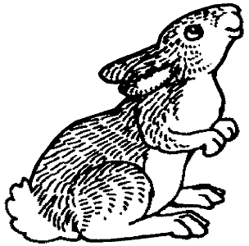
He decided to spend the day with his friend Cat.

Cat was in a thoughtful mood that day.
“Rabbit, can we really be sure this tale will end well?” he asked.
“You’ll be fine,” said Rabbit. And the two had fun watching odd videos online.

