Horse, Owl and Rooster
Horse often wondered what his tail looked like.
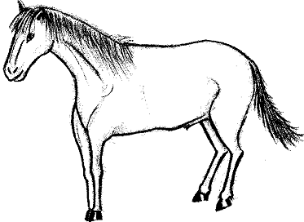
He decided to ask his friends.

Owl said – “I know what’s funny about your tail. There are no feathers in it.”
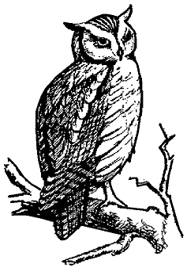
“On the other hand, maybe that’s how it is supposed to be.”

Rooster told Horse he was worrying over nothing.
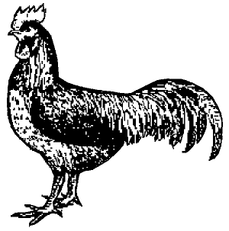
“I had laryngitis once, and couldn’t crow for a week. The sun kept rising anyway. So I wouldn’t worry.”

