Comparing and contrasting parallel texts

Learning objectives
At the end of this session, you will be able to:
- Use the Parallel passages tool to compare and contrast parallel texts
- Interpret the green shading in the texts and yellow shading in source texts
- Edit the text to make any necessary corrections
  - Ensure that what is the same in the source is the same
  - What is different in the source is different in your text
- Keep track of the passages that have been already been checked
- Identify any changes that have been made after marking a parallel text as checked
- Use a quick reference window and/or scroll groups to view passages in separate windows while translating
- Make sure Parallel Pages is in your plan

Demonstration

Accessing the Parallel Passages tool
- Make sure your project is active and in the desired book
- From the Tools menu, choose Parallel Passages

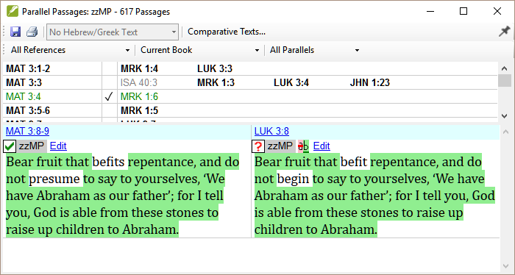
- Choose a comparative text, and source text with gloss (if appropriate)
- Set the filters as needed [All references, Current book, Synoptic gospels]
- Take a look at the screen, and text highlighting - particularly the green (matches two or more words) and yellow (same root), different panes.

Make changes to the text
- [Either] Modify a text: Click on the Edit link and make changes as necessary to the text
- [Or] Copying from one text to another:
  - Click on the Edit link.
  - Select and copy the text.
  - Click OK.
  - Click on the Edit link for the other text,
  - Select and Paste.
- Make any other corrections as necessary.

Mark the text as finished
- Click the checkbox below the verse reference to mark it as finished.

Identify any passages that have changed since checked
- In the Parallel passage tool, set the passages filter to “Changed text”
- Click on the ab in the lower pane
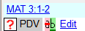
  - a compare text window opens in Paratext
- Edit the text as necessary
- Return to the Parallel passages tool using the icon on the taskbar.
- Click the checkbox to mark the text as “finished”.

Comparing passages while translating
The Parallel passages tool great to check after it has been translated. There are several ways you can see another passage in Paratext as you are translating, though this is not always recommended.
- To see one other passage:
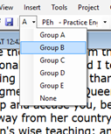
  - Open a quick reference window from Tools - Quick Reference.
The scroll group is automatically set to none.
  - Change the reference to the other passage,
your text will stay at the original verse.
- To see yet another passage:
  - Open a second copy of your project [File-Open] and
  - Change the scroll group from (A) to none.

Make sure Parallel Passages is in your plan
- Project - Project plan,
- Click on Checks tab,
- Under Other section, choose the stage.

Learning task 1
Using the practice project:
- With Matthew as the current book, open the parallel passages tool
- Setup the filters and texts needed.
- Check several verses, some suggestions:
  - Passages which must be the same
    - Mrk 1:6 and Mat 3:4
    - Mat 8:20 and Luk 9:58
    - MAT 11:6 and LUK 7:23
  - Passages which should be different
    - MAT 20:27 and MRK 10:44
    - MRK 9:45, MRK 9:43 and MRK 9:47
  - Display any changed verses and check/correct as necessary.

Learning task 2
Do you know what the colours and symbols mean? (See Paratext help topic: “What do the colors and symbols in the Parallel Passages tool mean?”)

Match the symbols with their meanings for the upper and lower pane:
Upper pane Lower pane
1 MAT 1:1 (black) a Approved 1 A Finished
2 MAT 1:1 (green) b Changed since approved 2 B No permission
3 MAT 1:1 (grey) c No text or verse no. missing 3 C No text/verse no.
4 MAT 1:1 (red ) d Not part of the project 4 D Not finished
5 MAT 1:1 (red) e Not yet approved 5 E Out of date
6 No checkbox F Verse missing

Answers:
Upper pane: 1e, 2a, 3d, 4c, 5b
Lower pane: 1B, 2D, 3A, 4E, 5F, 6C

Learning task 3 (optional)
If you finish the exercises early, compare the verses with different filters.
- Set Matthew as the current book
- How can you find the verses which are are not shown in the Synoptic gospels when it is a quote from the OT?

Summary
- Use the ________ ___________ tool to compare and contrast parallel texts.
- The green shading in the texts means _____________and yellow shading in source texts means that ____________________.
- Edit the text to make any necessary corrections
  - Ensure that what is the ______ in the source is the same in your texts
  - What is different in the source is the __________ in your text
- Use the _______________ to keep track of the passages that have been already been checked.
- You can identify any changes have been made after marking a parallel text as checked from the _____ (coloured) references in the top pane and the ____________ in the ___________ pane.
- It is generally not good practice to follow the first gospel passage when translating the ____ gospel passage. But it is good to follow either an OT quotation or a third gospel.
- You can use a ________ window and/or _____ groups to view passages in separate windows while translating.
- The Parallel passages check can be added to the project plan, from the checks tab, in ____, choose the stage.

Answers: Parallel Passages; two or more words are identical; same root word used; same; different; checkboxes; red; ?; lower: second, quick reference, scroll, other.

What are you taking away?

How will you use this learning in the future?

Resources: Paratext 8 help topics
- Introduction to the Parallel Passages tool
- What do the colors and symbols in the Parallel Passages tool mean?
- How do I include a check in a stage of project progress?

